**12. System Architecture**

**The Figure 12** This architecture diagram represents a web application based on the Model-View-Controller (MVC) design pattern. It illustrates the interaction between the core components of the application—Model, View, and Controller—and external systems like the Web Browser, Database, and Web API.

* The Web Browser initiates a request, which is handled by the Controller.
* The Controller acts as the central hub, processing the request and interacting with the Model to fetch or update data.
* The Model represents the application's data and business logic, and it communicates with the Database or external Web APIs to retrieve or store information.
* After processing, the Model sends data to the View, which is then rendered and returned to the Web Browser as a response.

This design promotes separation of concerns, modular development, and scalability, making it ideal for dynamic web applications.

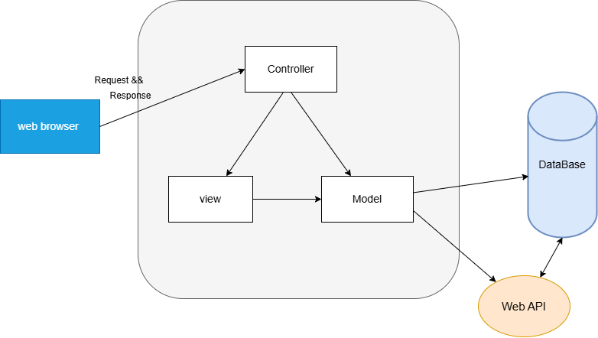

**Figure 12: MVC-Based Web Application Architecture**